**Physics 20 - Lesson 15**

**Forces & Dynamics – Problem Solving – Answer Key**

/ 122

1) 2 marks each for a total of 16 marks

A. Static

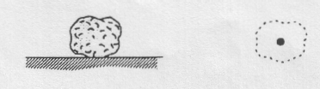

FN

Fg

C. Static

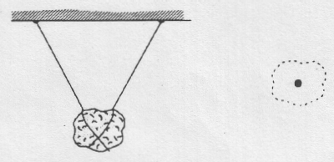

FT1

FT2

Fg

B. Static

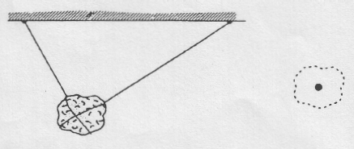

FT1

FT2

Fg

E. Rock is falling. Some air friction.

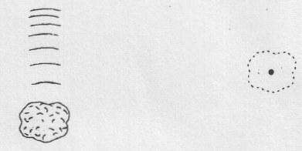

Ff

Fg

D. Rock is falling. No air friction.



Fg

F. Falling at constant (terminal) velocity.

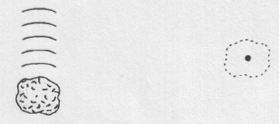

Ff

Fg

H. At the top of a parabolic trajectory.

No air resistance.

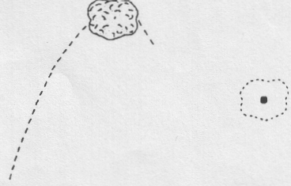

Fg

G. Rising in a parabolic trajectory.

No air resistance.

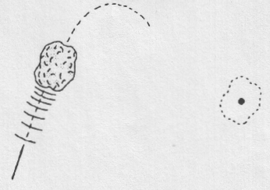

Fg

2)





/3



3)



/5



150N

500N



4)





/7



5)

/6



6)



/6

7)











/8



8)



/6





40N



30N

9)

/6

10)



10N

15N

10N



checkmark

15N



/5

11)



50N













30N

/10



9.38



60.36



12)



/8



13) a)









/6



b)







/6



c)







/6







40N

14)

/4

15)

A

B



Marble A



/10

Marble B

